REPORT SSIP PROJECT

Name: Daniel L. Tobing 001202400142

Class: CIT 4

Major: Informatics

Hello sir here I will explain the results of my project before I made a website, which is a list of perfume functions to record your expensive perfume perfume and there are some options that will certainly benefit users who have this website

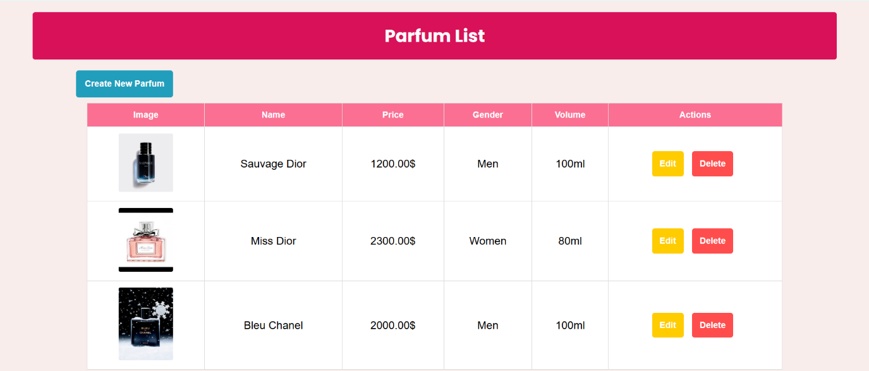And In accordance with applicable provisions, I created a simple website that contains CRUD

Here!! I made a feature that can make perfume delete perfume and edit for perfume that you want to change

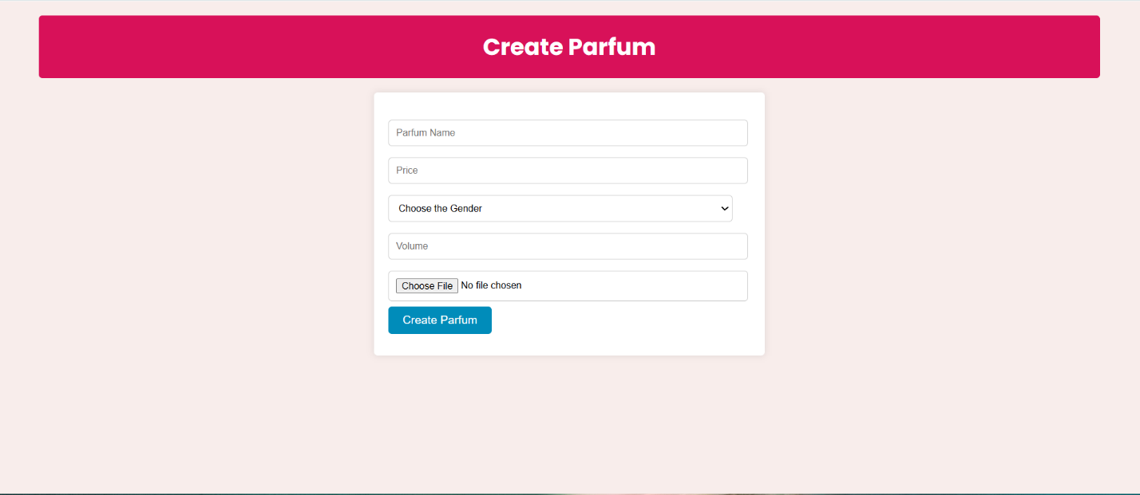

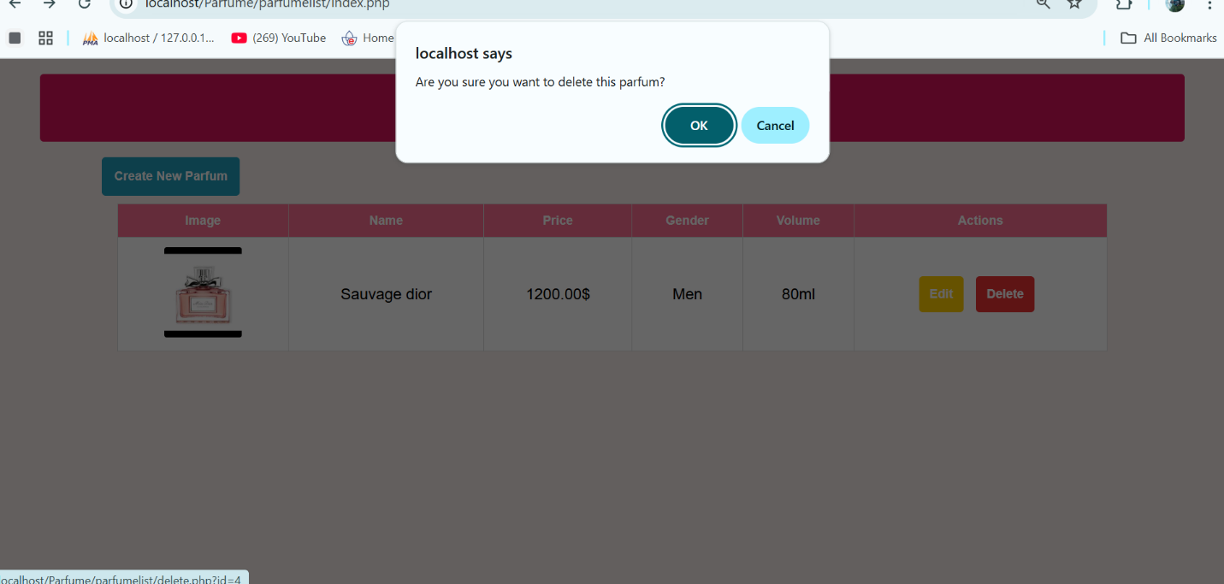This is if you want to add or update the perfume you want to enter.

and this is if you want to delete the perfume option that you want to delete

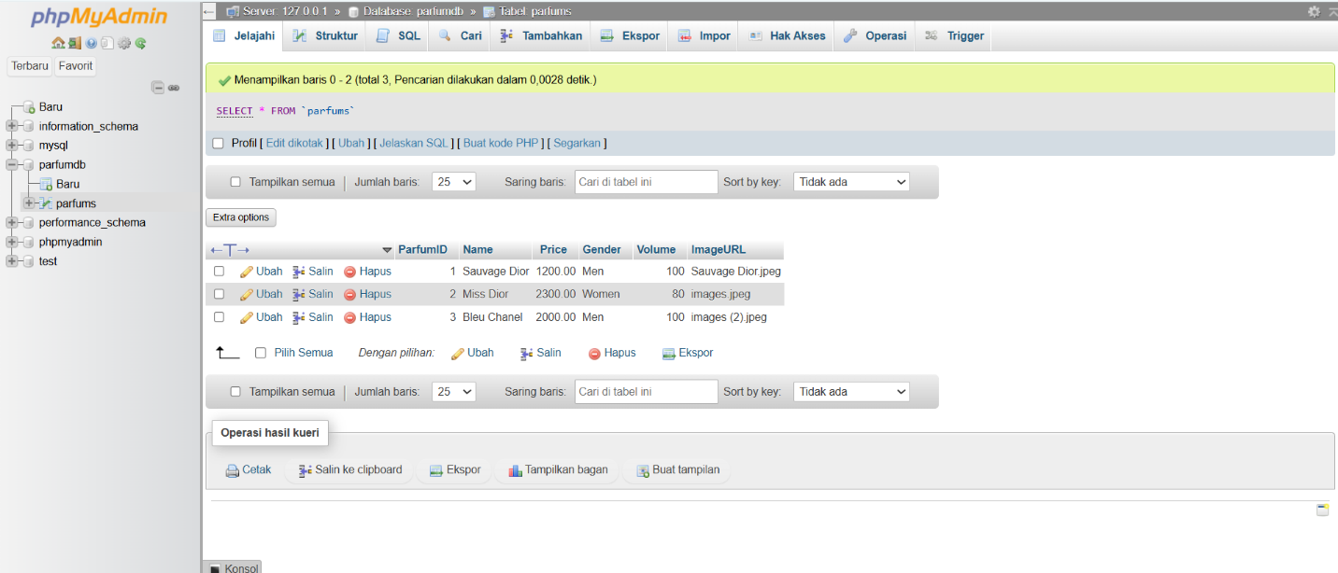

I use 1 mysql table for my website this time, and if you add another orfume then the data will be stored in mysql